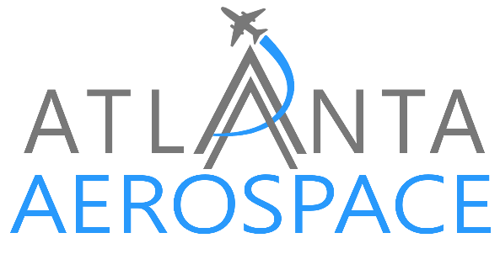

These General Terms and Conditions of Maintenance and Repair (the "General Terms") outline the agreements between "Poly-Fiber Enterprises Inc dba Atlanta Aerospace" (hereinafter referred to as "Poly-Fiber Enterprises Inc dba Atlanta Aerospace" or "ATLANTA AERO") and the Customer regarding the provision of Aircraft warranty and workmanship, liability, excusable delays, and repair services (the "Services").

1. WARRANTY
1.1 Services are warranted to comply with EASA Services are warranted to comply with EASA and 14 CFR 145 Repair Station (FAR Part 145) standards.
1.2 Services will be free from defects in workmanship.
1.3 Defects are covered if they arise within one (1) year from date of completion.
1.4 Warranty claims must be raised within 7 days of the defect becoming apparent, and the defective part must be provided within an additional 30 days.
1.5 Customer must prove the defect was due to ATLANTA AERO's improper performance.
1.6 Warranty does not cover Subcontractor/Supplier material or Services, but assignable rights will be transferred to the Customer.
1.7 Warranty does not cover damage due to misuse, incorrect use, force majeure or any damage occurring during transit to and/or from the ATLANTA AEROSPACE facility or any third party subcontracted by ATLANTA AEROSPACE or the Customer.
1.8 ATLANTA AERO will correct or replace defective Items at their discretion.
1.9 If the warranty claim is rejected, services and shipping fees will be charged to the Customer.
1.10 The warranties are exclusive, and Customer waives all other warranties and claims. ATLANTA AERO's liability is limited to the cost of correcting the defect or replacing the material.
1.11 Warranty is not assignable without ATLANTA AERO's written consent.

2. LIABILITY
2.1 ATLANTA AERO is not liable for any damage, loss, or injury to Customer's property or personnel unless caused by willful misconduct or gross negligence of ATLANTA AERO. Customer must indemnify ATLANTA AERO against such claims.
2.2 ATLANTA AERO is not liable or responsible for any damage sustained during transport of part(s) to and from ATLANTA AERO facility or any 3rd party facilities required or contracted by Customer or ATLANTA AERO to perform work.
2.3 Customer is liable for any damage or loss to ATLANTA AERO's property or personnel unless caused by ATLANTA AERO's willful misconduct or gross negligence.
2.4 ATLANTA AERO is not liable for indirect losses or damages such as loss of use, revenue, profit, or data.
2.5 ATLANTA AERO's total liability is limited to the price of the Service which gave rise to the claim.
2.6 Liability limitations are acknowledged and agreed by both parties.
3. EXCUSABLE DELAYS
3.1 The Parties agree that Poly-Fiber Enterprises Inc. dba Atlanta Aerospace (hereinafter "Atlanta Aerospace") will not be held liable if Turnaround Times, performance dates, or other agreed-upon time limits are not met due to reasons such as, but not limited to:
- (i) Force Majeure: Events beyond reasonable control, including acts of public enemy, war, insurrections, riots, fires, floods, explosions, earthquakes, serious accidents, epidemics, quarantine, governmental acts, strikes, labor troubles, or general transportation hindrance.
- (ii) Unforeseen Defects: Major, unforeseen defects on airframe, systems, engines, or components impacting the services.
- (iii) Customer Delays: Unavailability or late supply of materials, documentation, or responses by the Customer, or Customer not accepting suitable materials, or alternatives, offered by Atlanta Aerospace.
- (iv) Supplier Delays: Timely ordered materials not delivered on time or at all by Suppliers.
- (v) Consent Delays: Customer withholding or delaying required consents.
- (vi) Payment Delays: Customer's failure to comply with payment terms on current or past completed projects.
- (vii) Additional Tasks: Additional tasks requested by Customer that were not part of the original work scope.
- (viii) Rightful Stoppage: Atlanta Aerospace rightfully stopping or refusing to perform services.
3.2 If prevented by an Excusable Delay, the time for performance by Atlanta Aerospace will be extended by the number of business days equal to the delay period.

